**GENERAL HUMAN BIOLOGY – YEAR 12**

**TASK 7 – MICROSCOPE PRACTICAL**

***PART A – MICROSCOPE QUESTIONS [TOTAL =19 MARKS]***

1. Label the parts of the microscope in the picture below: [12 marks]

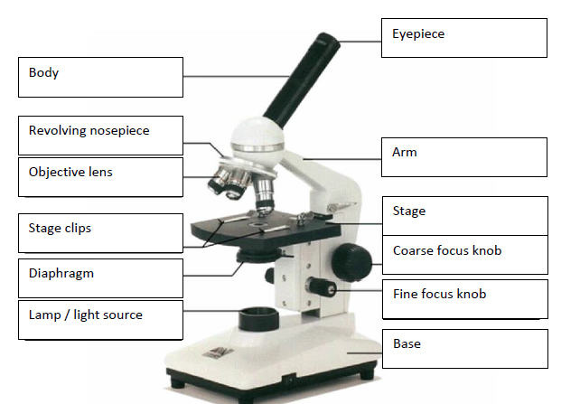

/ Ocular lens

1 mark per box

1. Calculate the missing information in the table below, using your knowledge of the powers of magnification. Make sure you SHOW YOUR WORKING IN THE SPACE PROVIDED TO GET FULL MARKS

[4 marks]

|  |  |  |  |
| --- | --- | --- | --- |
| OCULAR LENS | OBJECTIVE LENS | POWER OF MAGNIFICATION | WORKING OUT |
| 10 | 4 | 40 | 10 x 4 = 40 |
| 5 | 40 | 200 | 200 ÷ 5 = 40 |
| 12 | 10 | 120 | 120 ÷ 10 = 12 |

* *The calculations must be the correct way around (i.e. use division not multiply for 2nd and 3rd*

1. How does the view of a specimen on a microscope slide change as you increase the power of magnification ? [2 marks]

* Field of view decreases (1)
* More detail for image (1)

1. When should you *always* use the fine focus knob ? [1 mark]

* Using high power magnification (1)

***PART B –USING A MICROSCOPE [TOTAL = 12 MARKS]***

***OBSERVSATIONS:*** [8 marks]

Draw what you saw under the best magnification. *The bacteria will look like round cells with dots inside.*

* Minus one for each thing not covered included per drawing:
  + Date
  + Magnification
  + Pencil
  + Quality / appropriate magnification used

***ANALYSIS:***

1. Which slide showed the most bacteria? [1 mark]  
   Kefir
2. What power allowed you to view the bacteria the best? [1 mark]  
   Total magnification given – *must be appropriate choice*
3. Justify your answer for Question 6? [2 marks]  
   *Justification should refer to detail of specimen, field of view in relation to magnification*

***PART C –APPLICATIONS [TOTAL = 8 MARKS]***

1. As scientists have improved microscopes, so too has our understanding of micro-organisms such as bacteria and viruses. Why do you think this is so? [1 mark]

* Allowed us to view the small details of microorganisms which couldn’t before

1. Answer the following calculations:
   1. 5210 µm = 5.21 mm [1 mark]
   2. 0.154mm = 154 µm [1 mark]
   3. A microscope has a Field of View of 2.5cm at magnification 40x.
      1. Convert the Field of View to micrometres = 25000 µm [2 marks]  
         *Show working here:*  
         *correct working*
      2. If the magnification was increased to 400x, what would the new Field of View be? = 2500 µm [2 marks]  
         *Show working here:*

*Correct working*

***END OF TEST***